Practical No: 03
Aim:Object Identification and Counting on Web Page Tool: Selenium WebDriver Write a program to identify and count the total number of objects present on a web page including links, images, buttons, and input elements. Display categorized counts.
PRE-REQUISITES:
1) Check that you have JDK.
2) Check that you have Eclipse IDE.
3) Check that you have Selenium Server Driver and Client
Driver(JAR files). 4) Check that you have Gecko Driver.
5) Check that you have a stable Internet connection.
STEPS:
1) Open Eclipse. Select your workspace directory. Click Launch:
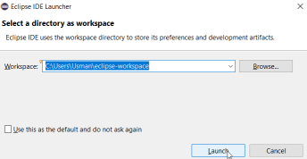2) Create a Project(File > New > Java Project):
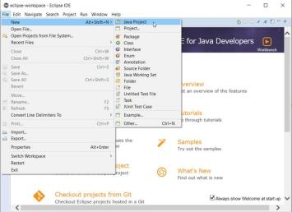
3) Name the project as “p8” > click Finish > click Don’t Create module: 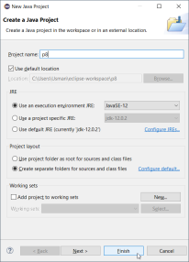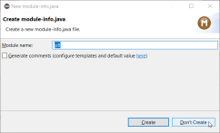4) Close the “Welcome” tab.
5) Create a Package(right-click on Project Name > New > Package > Name it > Finish:
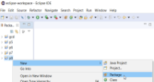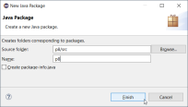6) Create a Class(right-click on Project Name > New > Class > Name it > Finish: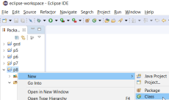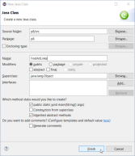
7) Adding “Selenium Server Driver and Client Driver(JAR files)” in Eclipse IDE: • right-click on Project Name > Build Path >
Configure Build Path
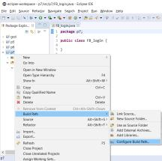
• now go under: Java Build Path > Libraries > Classpath > click Add
External JARs…
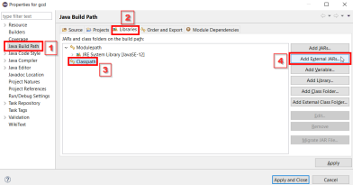• Browse and add JAR files > click Apply and Close :
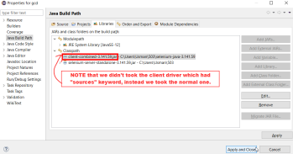8) Creating the script in JAVA:
(NOTE that this script will be run by Eclipse IDE)
(In simple words, it’s like we are
-ordering Eclipse to run a script or to do a job
-of opening the browser, visiting the URL
-and finding the <a> tag WebElements with the help of Selenium Drivers -and to show the result.
-Hence automating the work in browser)
• Now we’ll put the path of “geckodriver” in a String driverPath
---(FindAllLinks.java)---
package p8;
import org.openqa.selenium.By;
import org.openqa.selenium.WebDriver;
import org.openqa.selenium.WebElement;
import org.openqa.selenium.firefox.FirefoxDriver;
import org.openqa.selenium.firefox.*;
import org.openqa.selenium.firefox.FirefoxOptions;
import org.openqa.selenium.firefox.FirefoxProfile;
import org.openqa.selenium.firefox.internal.ProfilesIni;
public class FindAllLinks {
static String driverPath = "C:\\Users\\Usman\\503\\geckodriver.exe"; public static void main(String[] args) {
System.setProperty("webdriver.gecko.driver",driverPath);
//NOTE THAT: following commented lines are required for old machines
//DesiredCapabilities capabilities = DesiredCapabilities.firefox();
//capabilities.setCapability("marionette",true); //ProfilesIni allProfiles = new ProfilesIni(); //FirefoxProfile fp = new FirefoxProfile();
//fp.setPreference(FirefoxProfile.PORT_PREFERENCE,"7055"); //FirefoxOptions options = new FirefoxOptions(); //options.setProfile(fp);
WebDriver driver = new FirefoxDriver();
String appUrl ="https://www.google.co.in/";
driver.get(appUrl);
java.util.List<WebElement> links =
driver.findElements(By.tagName("a"));
for (int i = 1; i<links.size(); i=i+1)
{
System.out.println(links.get(i).getText());
}
System.out.println("Total No. of Links: "+links.size());
//driver.quit();
}
}
9) Run the file from Eclipse IDE: OUTPUT:


